ASSIGNMENT NO.2

GAURAV_BODKHE_2124UCEM1041

1. Introduction
We have to develop a program that implement restaurant data entry form with a table layout. It allows restaurant owners first to enter details of Login credentials like Username,Password And on next page enter details uses a table layout to create a restaurant data entry form. Include fields like "Restaurant Name," "Location," and "Cuisine Type." Add a set of radio buttons to let the user select the type of restaurant (e.g., "Fast Food," "Fine Dining," or "Cafe"). Use this to design a user-friendly interface for restaurant owners to input their data.

2. Tools & Technologies Used
- Android Studio
- Java/Kotlin
- Emulator

3. Procedure & Steps

Step 1: Create a New Project
- Open Android Studio and create a new project.
- Choose an Bottom navigation Views Activity template.
- Set the project name and package name of your Application
- Select the programming language (Java/Kotlin).
- Screenshot:
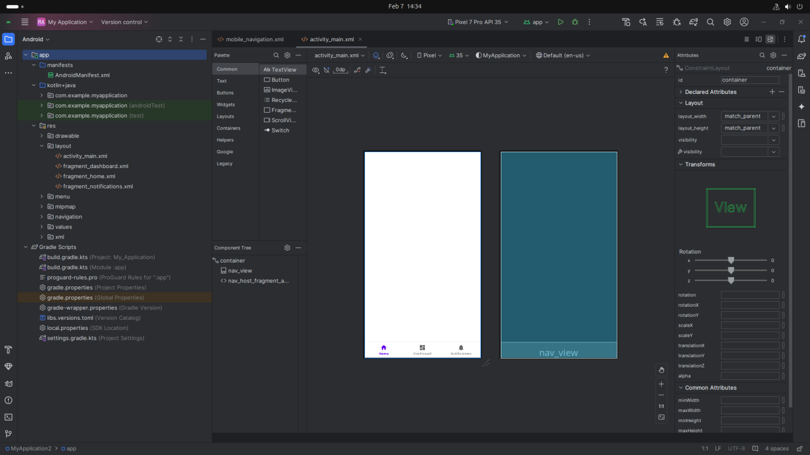

Step 2: Designing the UI
- Open activity_main.xml and design the layout using XML.
- Add UI comwponents such as TextView, EditText, Button, etc.
Screenshot:

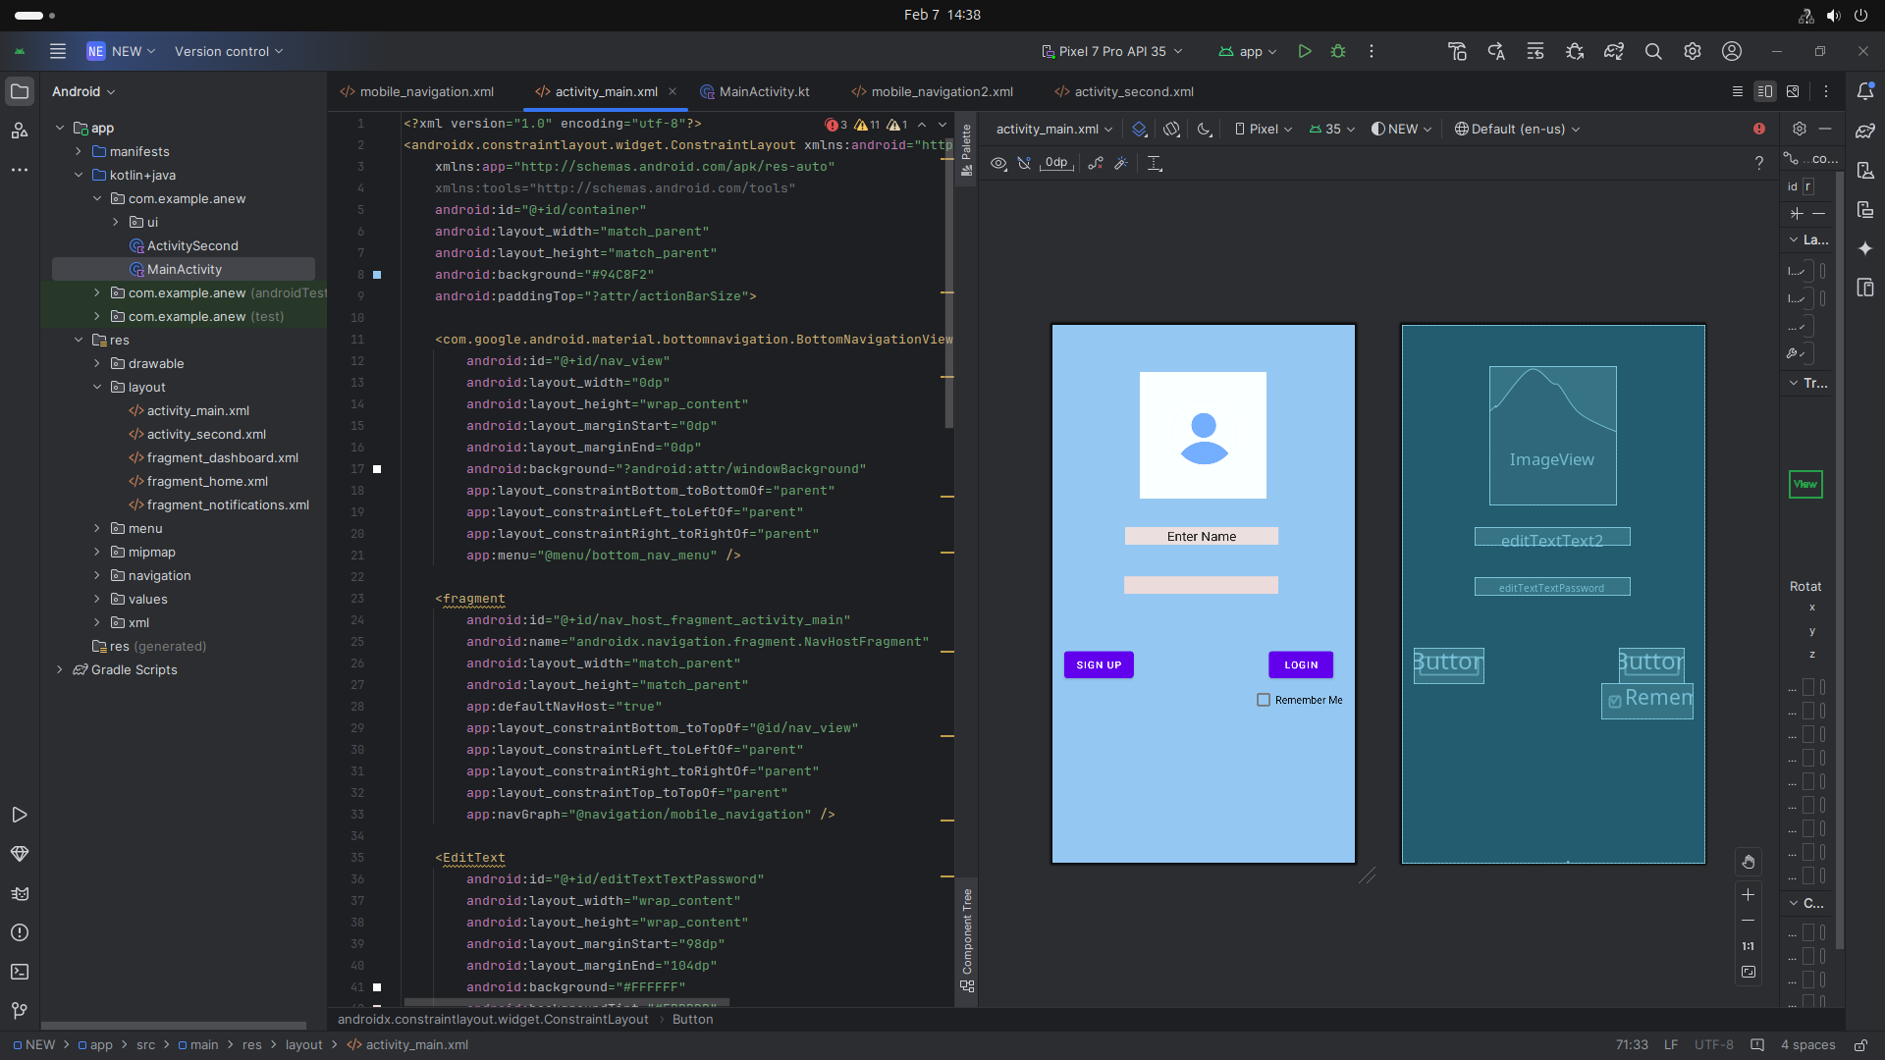

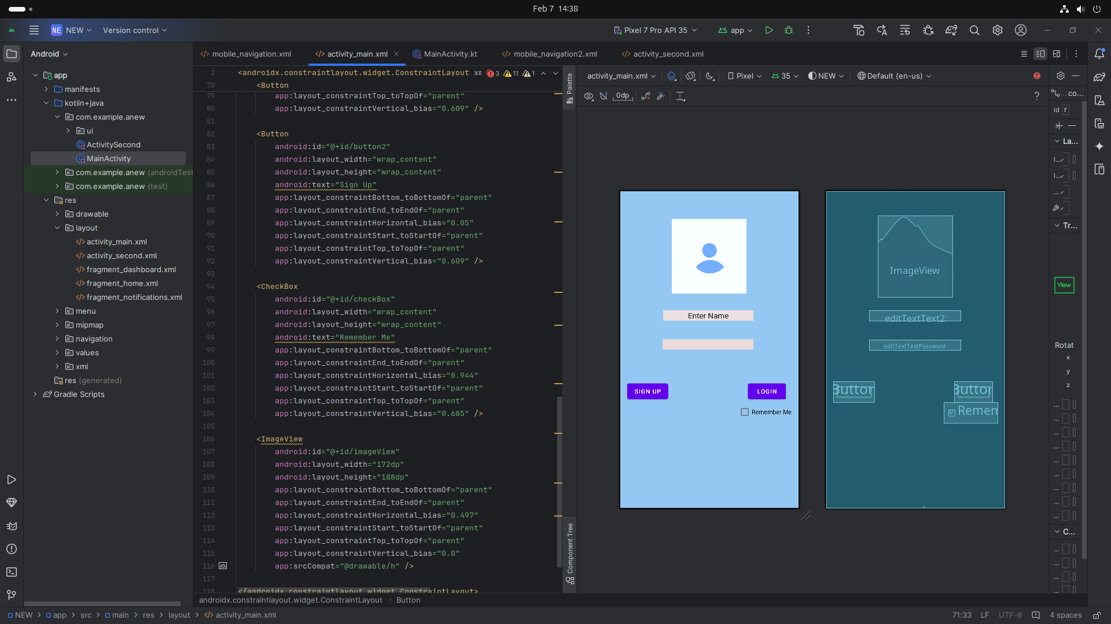

Step 3: Writing the Code
- Open MainActivity.java or MainActivity.kt.
- Implement functionality such as Username,Password,Login(button),Restaurant name
- Use necessary Android components like Intents, RecyclerView, Fragments, etc
Xml=

<?xml version="1.0" encoding="utf-8"?>

<androidx.constraintlayout.widget.ConstraintLayout xmlns:android="http://schemas.android.com/apk/res/android"

xmlns:app="http://schemas.android.com/apk/res-auto"

xmlns:tools="http://schemas.android.com/tools"

android:id="@+id/container"

android:layout_width="match_parent"

android:layout_height="match_parent"

android:background="#94C8F2"

android:paddingTop="?attr/actionBarSize">

<com.google.android.material.bottomnavigation.BottomNavigationView

android:id="@+id/nav_view"

android:layout_width="0dp"

android:layout_height="wrap_content"

android:layout_marginStart="0dp"

android:layout_marginEnd="0dp"

android:background="?android:attr/windowBackground"

app:layout_constraintBottom_toBottomOf="parent"

app:layout_constraintLeft_toLeftOf="parent"

app:layout_constraintRight_toRightOf="parent"

app:menu="@menu/bottom_nav_menu" />

<fragment

android:id="@+id/nav_host_fragment_activity_main"

android:name="androidx.navigation.fragment.NavHostFragment"

android:layout_width="match_parent"

android:layout_height="match_parent"

app:defaultNavHost="true"

app:layout_constraintBottom_toTopOf="@id/nav_view"

app:layout_constraintLeft_toLeftOf="parent"

app:layout_constraintRight_toRightOf="parent"

app:layout_constraintTop_toTopOf="parent"

app:navGraph="@navigation/mobile_navigation" />

<EditText

android:id="@+id/editTextTextPassword"

android:layout_width="wrap_content"

android:layout_height="wrap_content"

android:layout_marginStart="98dp"

android:layout_marginEnd="104dp"

android:background="#FFFFFF"

android:backgroundTint="#EBDBDB"

android:ems="10"

android:inputType="textPassword"

app:layout_constraintBottom_toBottomOf="parent"

app:layout_constraintEnd_toEndOf="parent"

app:layout_constraintHorizontal_bias="1.0"

app:layout_constraintStart_toStartOf="parent"

app:layout_constraintTop_toTopOf="parent"

app:layout_constraintVertical_bias="0.439" />

<EditText

android:id="@+id/editTextText2"

android:layout_width="wrap_content"

android:layout_height="wrap_content"

android:background="#FBFBFB"

android:backgroundTint="#EBDFDF"

android:ems="10"

android:inputType="text"

android:text="Enter Name"

android:textAlignment="center"

app:layout_constraintBottom_toBottomOf="parent"

app:layout_constraintEnd_toEndOf="parent"

app:layout_constraintHorizontal_bias="0.487"

app:layout_constraintStart_toStartOf="parent"

app:layout_constraintTop_toTopOf="parent"

app:layout_constraintVertical_bias="0.336" />

<Button

android:id="@+id/button"

android:layout_width="wrap_content"

android:layout_height="wrap_content"

android:text="Login"

app:layout_constraintBottom_toBottomOf="parent"

app:layout_constraintEnd_toEndOf="parent"

app:layout_constraintHorizontal_bias="0.91"

app:layout_constraintStart_toStartOf="parent"

app:layout_constraintTop_toTopOf="parent"

app:layout_constraintVertical_bias="0.609" />

<Button

android:id="@+id/button2"

android:layout_width="wrap_content"

android:layout_height="wrap_content"

android:text="Sign Up"

app:layout_constraintBottom_toBottomOf="parent"

app:layout_constraintEnd_toEndOf="parent"

app:layout_constraintHorizontal_bias="0.05"

app:layout_constraintStart_toStartOf="parent"

app:layout_constraintTop_toTopOf="parent"

app:layout_constraintVertical_bias="0.609" />

<CheckBox

android:id="@+id/checkBox"

android:layout_width="wrap_content"

android:layout_height="wrap_content"

android:text="Remember Me"

app:layout_constraintBottom_toBottomOf="parent"

app:layout_constraintEnd_toEndOf="parent"

app:layout_constraintHorizontal_bias="0.944"

app:layout_constraintStart_toStartOf="parent"

app:layout_constraintTop_toTopOf="parent"

app:layout_constraintVertical_bias="0.685" />

<ImageView

android:id="@+id/imageView"

android:layout_width="172dp"

android:layout_height="188dp"

app:layout_constraintBottom_toBottomOf="parent"

app:layout_constraintEnd_toEndOf="parent"

app:layout_constraintHorizontal_bias="0.497"

app:layout_constraintStart_toStartOf="parent"

app:layout_constraintTop_toTopOf="parent"

app:layout_constraintVertical_bias="0.0"

app:srcCompat="@drawable/h" />

</androidx.constraintlayout.widget.ConstraintLayout>

4. Procedure & Steps(second page of restaurant App)

Step 1: Create a New Activity
- Go to App section (Right click) Click on New
- Choose An Activity
- Select an Empty Views Activity
- Set the project name and package name of your Application
- Select the programming language (Java/Kotlin).
- Screenshot:
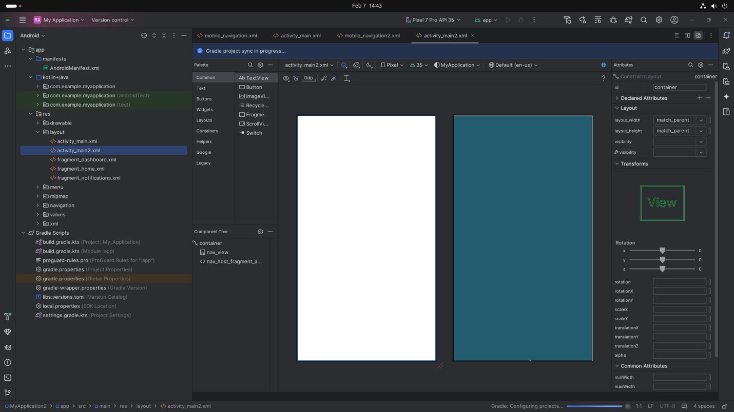

Step 2: Designing the UI
- Open activity_main2.xml and design the layout using XML.
- Add UI comwponents such as TextView, EditText,Radio Button,image etc.
Screenshot:

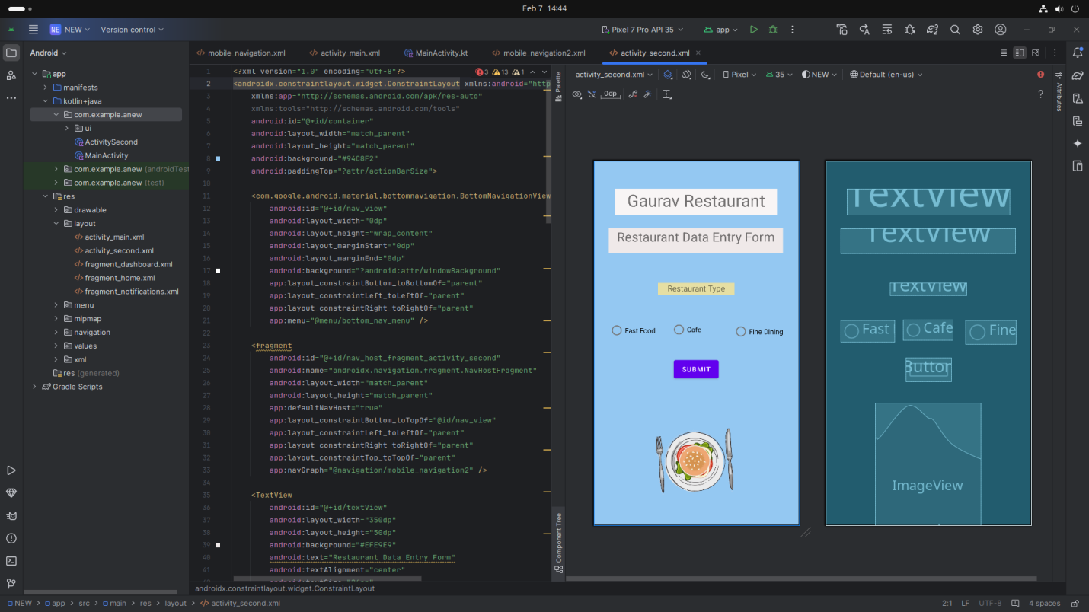

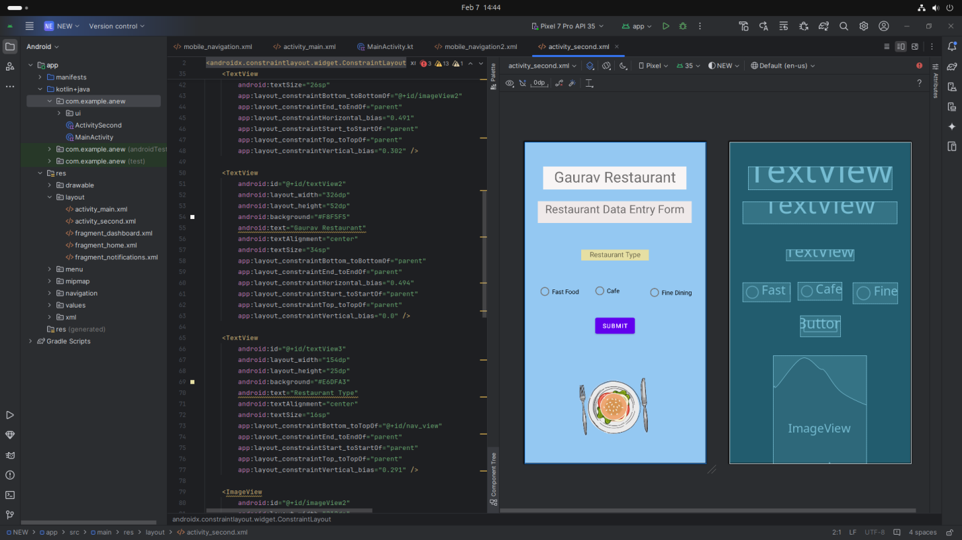

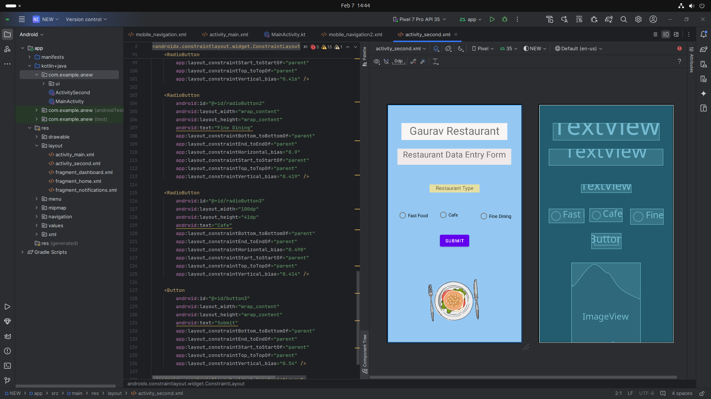

Step 3: Writing the Code
- Open MainActivity.java or MainActivity2.kt.
- Implement functionality such as Username,Password,Login(button),Restaurant name
- Use necessary Android components like Intents, RecyclerView, Fragments, etc
Xml=

<?xml version="1.0" encoding="utf-8"?>

<androidx.constraintlayout.widget.ConstraintLayout xmlns:android="http://schemas.android.com/apk/res/android"

xmlns:app="http://schemas.android.com/apk/res-auto"

xmlns:tools="http://schemas.android.com/tools"

android:id="@+id/container"

android:layout_width="match_parent"

android:layout_height="match_parent"

android:background="#94C8F2"

android:paddingTop="?attr/actionBarSize">

<com.google.android.material.bottomnavigation.BottomNavigationView

android:id="@+id/nav_view"

android:layout_width="0dp"

android:layout_height="wrap_content"

android:layout_marginStart="0dp"

android:layout_marginEnd="0dp"

android:background="?android:attr/windowBackground"

app:layout_constraintBottom_toBottomOf="parent"

app:layout_constraintLeft_toLeftOf="parent"

app:layout_constraintRight_toRightOf="parent"

app:menu="@menu/bottom_nav_menu" />

<fragment

android:id="@+id/nav_host_fragment_activity_second"

android:name="androidx.navigation.fragment.NavHostFragment"

android:layout_width="match_parent"

android:layout_height="match_parent"

app:defaultNavHost="true"

app:layout_constraintBottom_toTopOf="@id/nav_view"

app:layout_constraintLeft_toLeftOf="parent"

app:layout_constraintRight_toRightOf="parent"

app:layout_constraintTop_toTopOf="parent"

app:navGraph="@navigation/mobile_navigation2" />

<TextView

android:id="@+id/textView"

android:layout_width="350dp"

android:layout_height="50dp"

android:background="#EFE9E9"

android:text="Restaurant Data Entry Form"

android:textAlignment="center"

android:textSize="26sp"

app:layout_constraintBottom_toBottomOf="@+id/imageView2"

app:layout_constraintEnd_toEndOf="parent"

app:layout_constraintHorizontal_bias="0.491"

app:layout_constraintStart_toStartOf="parent"

app:layout_constraintTop_toTopOf="parent"

app:layout_constraintVertical_bias="0.302" />

<TextView

android:id="@+id/textView2"

android:layout_width="326dp"

android:layout_height="52dp"

android:background="#F8F5F5"

android:text="Gaurav Restaurant"

android:textAlignment="center"

android:textSize="34sp"

app:layout_constraintBottom_toBottomOf="parent"

app:layout_constraintEnd_toEndOf="parent"

app:layout_constraintHorizontal_bias="0.494"

app:layout_constraintStart_toStartOf="parent"

app:layout_constraintTop_toTopOf="parent"

app:layout_constraintVertical_bias="0.0" />

<TextView

android:id="@+id/textView3"

android:layout_width="154dp"

android:layout_height="25dp"

android:background="#E6DFA3"

android:text="Restaurant Type"

android:textAlignment="center"

android:textSize="16sp"

app:layout_constraintBottom_toTopOf="@+id/nav_view"

app:layout_constraintEnd_toEndOf="parent"

app:layout_constraintStart_toStartOf="parent"

app:layout_constraintTop_toTopOf="parent"

app:layout_constraintVertical_bias="0.291" />

<ImageView

android:id="@+id/imageView2"

android:layout_width="212dp"

android:layout_height="246dp"

app:layout_constraintBottom_toBottomOf="parent"

app:layout_constraintEnd_toEndOf="parent"

app:layout_constraintHorizontal_bias="0.497"

app:layout_constraintStart_toStartOf="parent"

app:layout_constraintTop_toTopOf="parent"

app:layout_constraintVertical_bias="1.0"

app:srcCompat="@drawable/f" />

<RadioButton

android:id="@+id/radioButton"

android:layout_width="108dp"

android:layout_height="43dp"

android:text="Fast Food"

app:layout_constraintBottom_toBottomOf="parent"

app:layout_constraintEnd_toEndOf="parent"

app:layout_constraintHorizontal_bias="0.099"

app:layout_constraintStart_toStartOf="parent"

app:layout_constraintTop_toTopOf="parent"

app:layout_constraintVertical_bias="0.416" />

<RadioButton

android:id="@+id/radioButton2"

android:layout_width="wrap_content"

android:layout_height="wrap_content"

android:text="Fine Dining"

app:layout_constraintBottom_toBottomOf="parent"

app:layout_constraintEnd_toEndOf="parent"

app:layout_constraintHorizontal_bias="0.9"

app:layout_constraintStart_toStartOf="parent"

app:layout_constraintTop_toTopOf="parent"

app:layout_constraintVertical_bias="0.419" />

<RadioButton

android:id="@+id/radioButton3"

android:layout_width="100dp"

android:layout_height="41dp"

android:text="Cafe"

app:layout_constraintBottom_toBottomOf="parent"

app:layout_constraintEnd_toEndOf="parent"

app:layout_constraintHorizontal_bias="0.498"

app:layout_constraintStart_toStartOf="parent"

app:layout_constraintTop_toTopOf="parent"

app:layout_constraintVertical_bias="0.414" />

<Button

android:id="@+id/button3"

android:layout_width="wrap_content"

android:layout_height="wrap_content"

android:text="Submit"

app:layout_constraintBottom_toBottomOf="parent"

app:layout_constraintEnd_toEndOf="parent"

app:layout_constraintStart_toStartOf="parent"

app:layout_constraintTop_toTopOf="parent"

app:layout_constraintVertical_bias="0.54" />

</androidx.constraintlayout.widget.ConstraintLayout>

Step 5: Writing the Backend Code

For first Page=
- Open MainActivity.java or MainActivity.kt.
- Implement functionality such as By Click on Button Go to Next Activity
Screenshot:
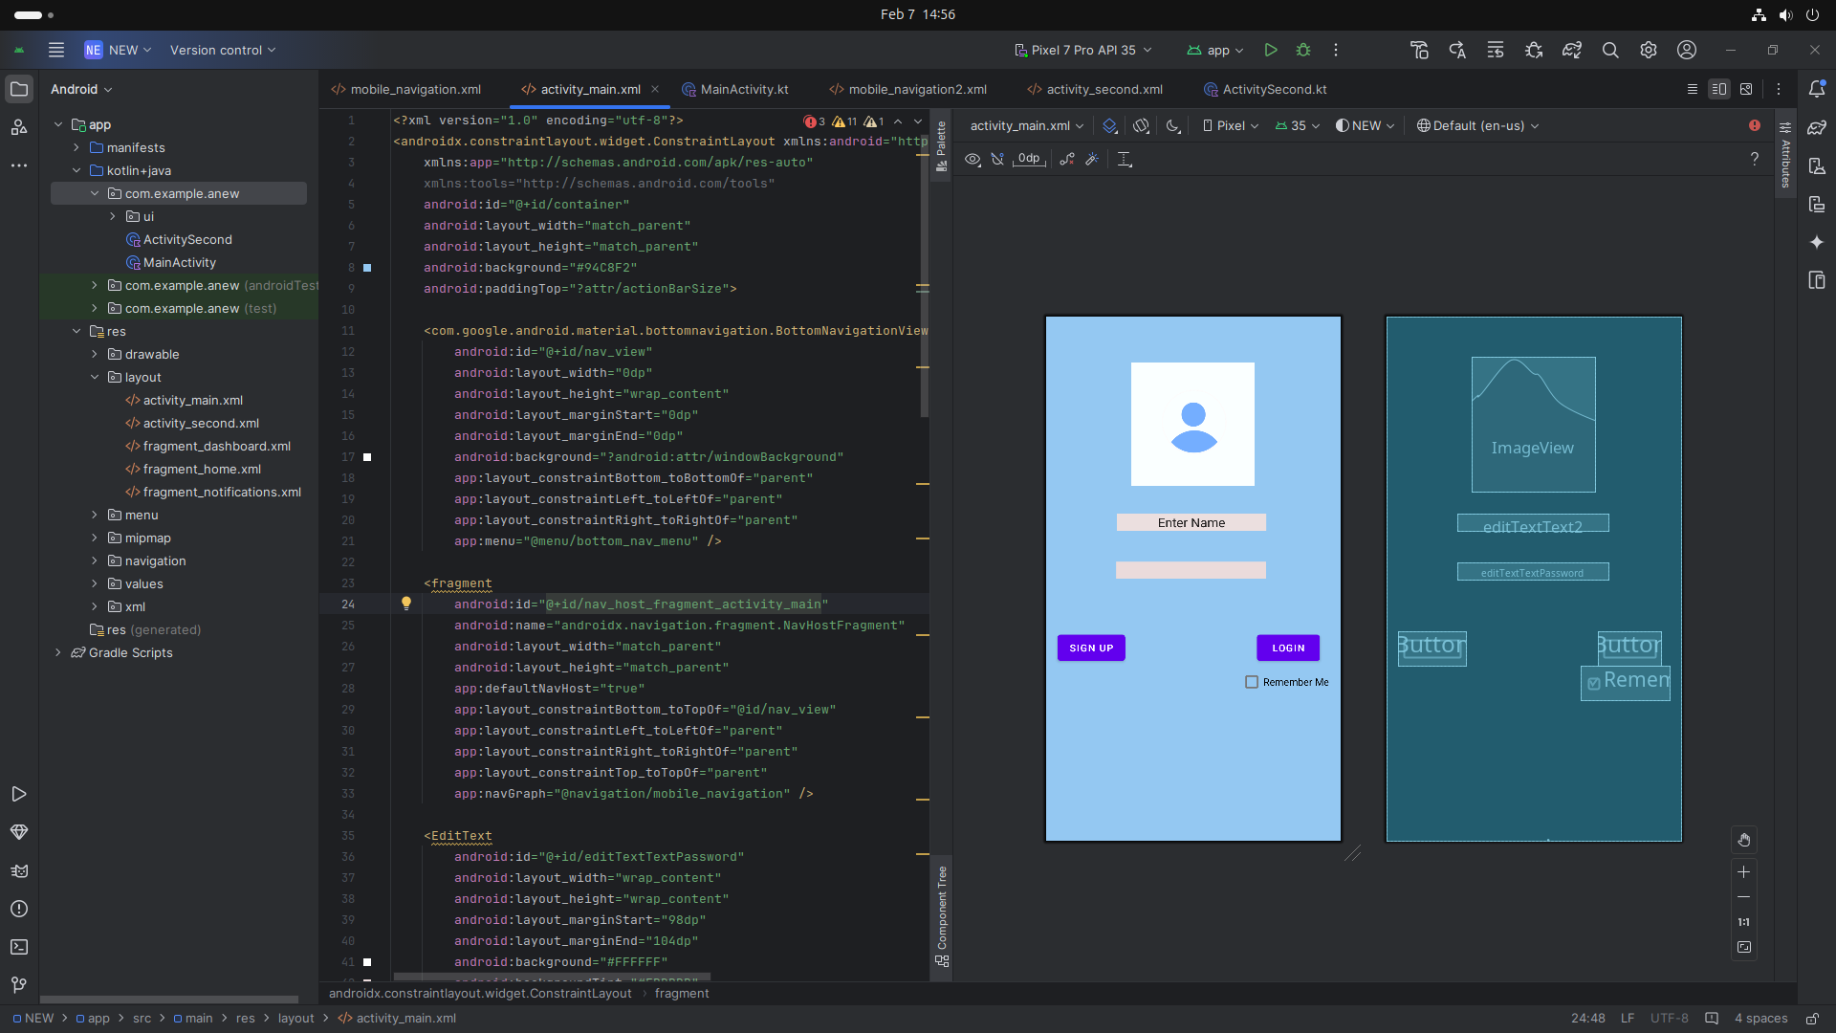
Kotlin:

Code:
package com.example.anew

import android.content.Intent
import android.os.Bundle
import android.widget.Button
import com.google.android.material.bottomnavigation.BottomNavigationView
import androidx.appcompat.app.AppCompatActivity
import androidx.navigation.findNavController
import androidx.navigation.ui.AppBarConfiguration
import androidx.navigation.ui.setupActionBarWithNavController
import androidx.navigation.ui.setupWithNavController
import com.example.anew.databinding.ActivityMainBinding

class MainActivity : AppCompatActivity() {

private lateinit var binding: ActivityMainBinding

override fun onCreate(savedInstanceState: Bundle?) {
super.onCreate(savedInstanceState)

binding = ActivityMainBinding.inflate(layoutInflater)
setContentView(binding.root)

val navView: BottomNavigationView = binding.navView

val navController = findNavController(R.id.nav_host_fragment_activity_main)
// Passing each menu ID as a set of Ids because each
// menu should be considered as top level destinations.
val appBarConfiguration = AppBarConfiguration(
setOf(
R.id.navigation_home, R.id.navigation_dashboard, R.id.navigation_notifications
)
)
setupActionBarWithNavController(navController, appBarConfiguration)
navView.setupWithNavController(navController)
val activity2ctbutton = findViewById<Button>(R.id.button)
activity2ctbutton.setOnClickListener() {
val Intent = Intent( this, activity2ctbutton::class.java)
startActivity(Intent)
}
}
}

For Second Page=
Screenshot:
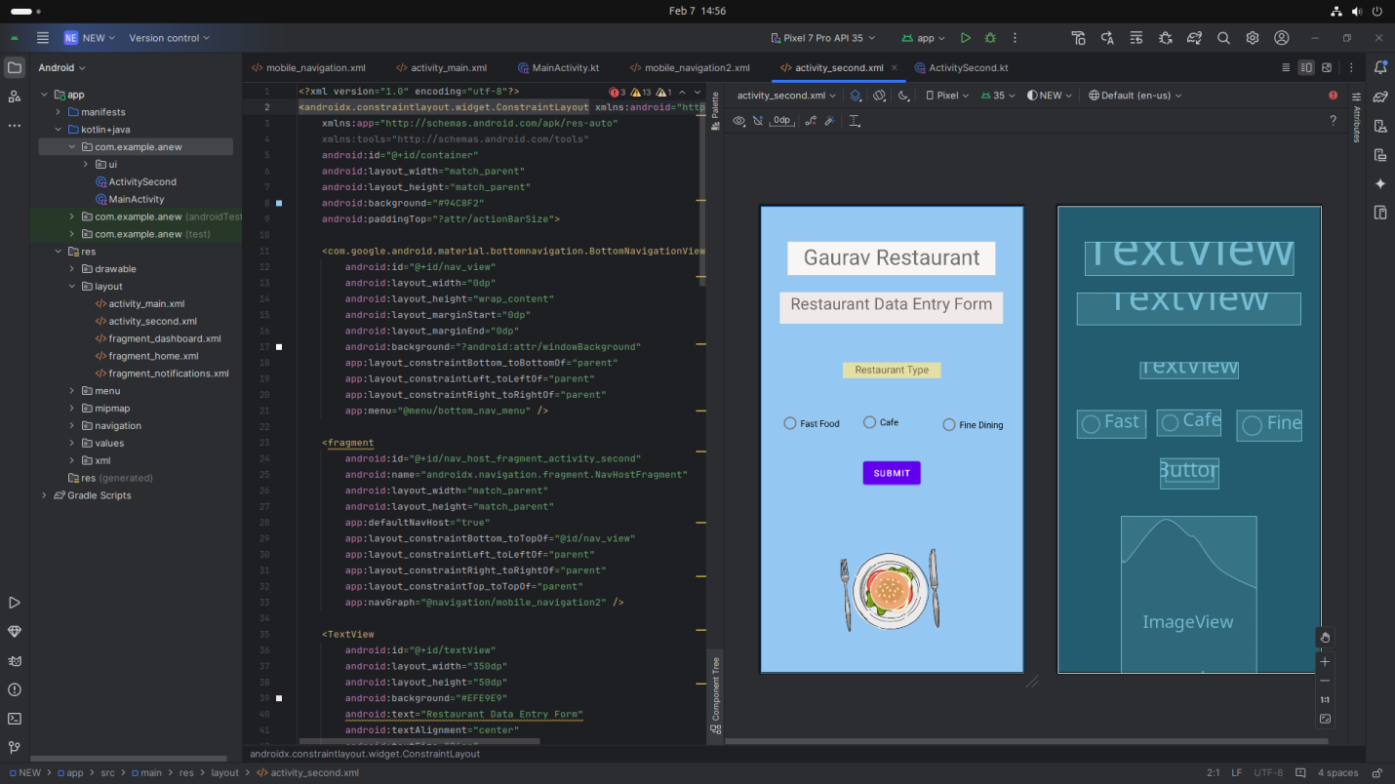
Kotlin:
package com.example.anew

import android.os.Bundle
import com.google.android.material.bottomnavigation.BottomNavigationView
import androidx.appcompat.app.AppCompatActivity
import androidx.navigation.findNavController
import androidx.navigation.ui.AppBarConfiguration
import androidx.navigation.ui.setupActionBarWithNavController
import androidx.navigation.ui.setupWithNavController
import com.example.anew.databinding.ActivitySecondBinding

class ActivitySecond : AppCompatActivity() {

private lateinit var binding: ActivitySecondBinding

override fun onCreate(savedInstanceState: Bundle?) {
super.onCreate(savedInstanceState)

binding = ActivitySecondBinding.inflate(layoutInflater)
setContentView(binding.root)

val navView: BottomNavigationView = binding.navView

val navController = findNavController(R.id.nav_host_fragment_activity_second)
// Passing each menu ID as a set of Ids because each
// menu should be considered as top level destinations.
val appBarConfiguration = AppBarConfiguration(
setOf(
R.id.navigation_home, R.id.navigation_dashboard, R.id.navigation_notifications
)
)
setupActionBarWithNavController(navController, appBarConfiguration)
navView.setupWithNavController(navController)
}
}

Step 6: Running the Application on Emulator
- Click on the Run button in Android Studio.
- Select the emulator and launch the app.
Screenshot:
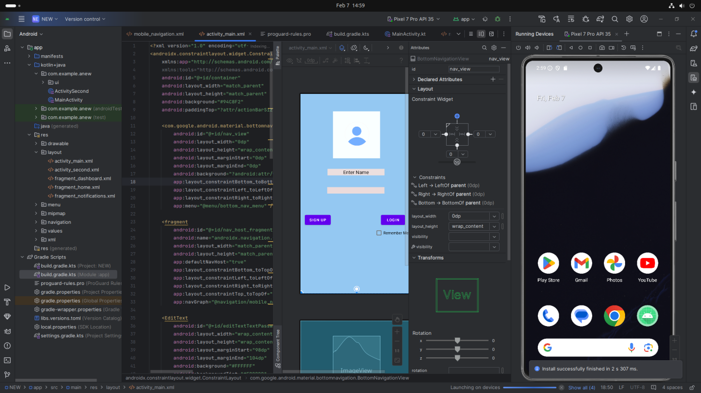

Step 7: Testing & Output
- Test different functionalities of the app.
- Capture the output results.
- Screenshot:
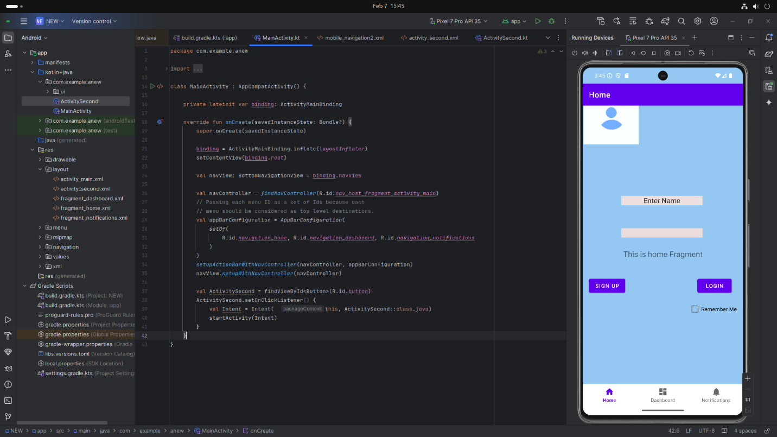

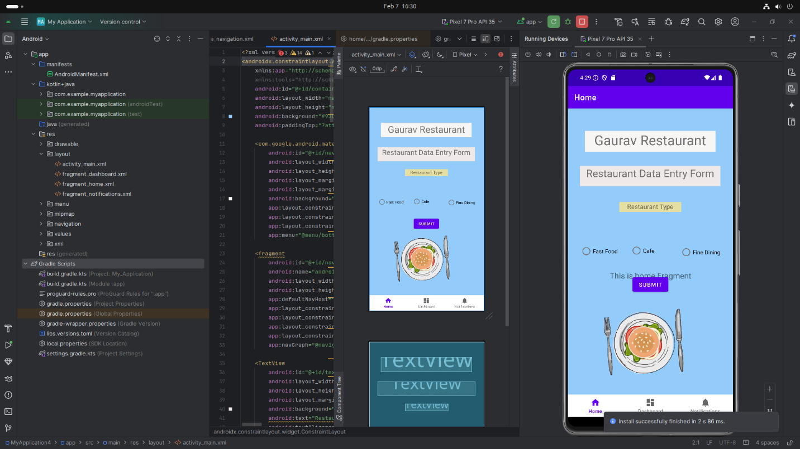

4. Conclusion
I learned a lot about creating a restaurant data entry form using a table layout in Kotlin and Java for Android development. I gained new skills, like how to design a user-friendly interface with fields for restaurant name, location, cuisine type, and radio buttons for restaurant type selection. Some challenges I faced included figuring out how to properly organize the layout and ensure all fields were correctly linked, but I was able to overcome these by researching and experimenting with the code. In the end, I feel more confident in my ability to create forms and solve layout-related problems. This experience also helped me improve my problem-solving skills and manage my time better.
窗体顶端
窗体底端
.

